**Google Fiber Executive Summaries**

by Harbir Aujla

## Repeats by Month

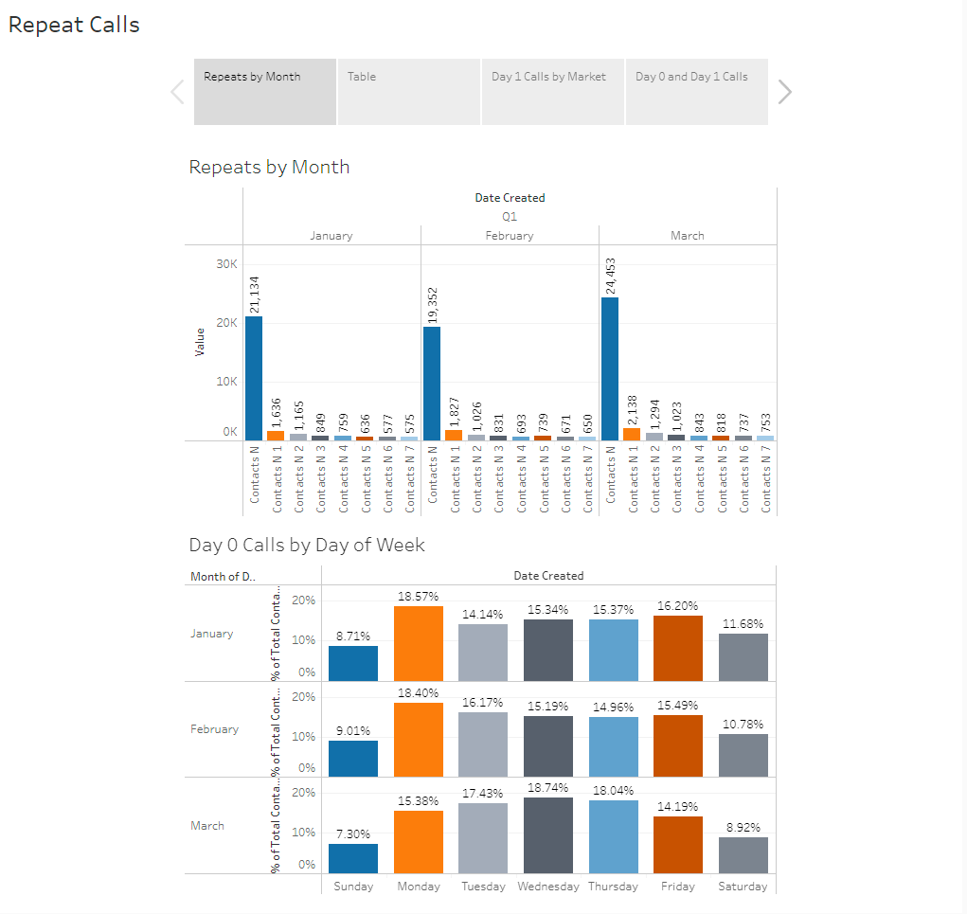

The first tab of the dashboard includes two bar charts: the first chart visualizes the number of repeat calls the customer service team received each month. Contacts_N represents the first date a customer called– then, you can explore how often the customer called again that week. For example, 1,636 customers called again one day after their initial call, but only 575 customers called again seven days later in January.

The second chart visualized the percentage of first contact calls by day of the week; in January, only 8.71% of customers made first contact on Sunday. The majority of customers reached out for the first time on Monday in January!

**Tables**

The second tab of the dashboard includes two tables: Repeat Calls by First Call Date and Calls by Market and Type.

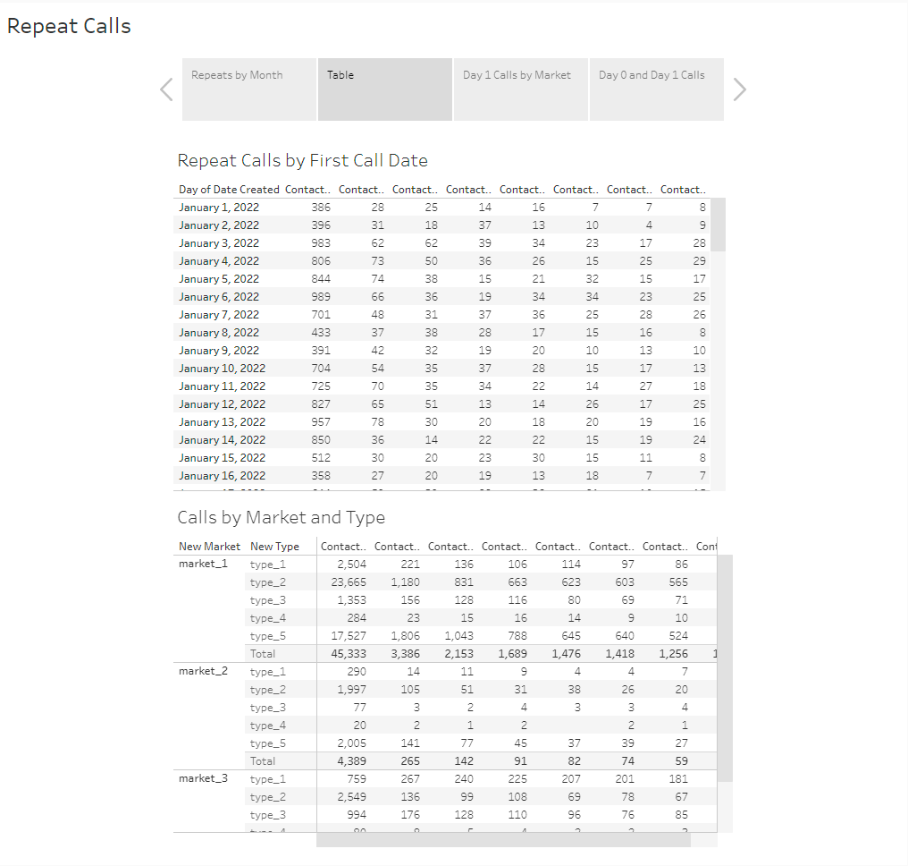

The first table allows stakeholders to explore the number of different types of calls by date. The second table then separates calls into market and problem type to provide more specific information about what markets experience the most calls and the problems customers have that seem to prompt repeat calls.

### Market and Type for First Repeat Calls

The Market and Type for First Repeat Calls uses the data from the previous tabs table in order to further visualize the problem types that seem to generate the most repeat calls for different markets.

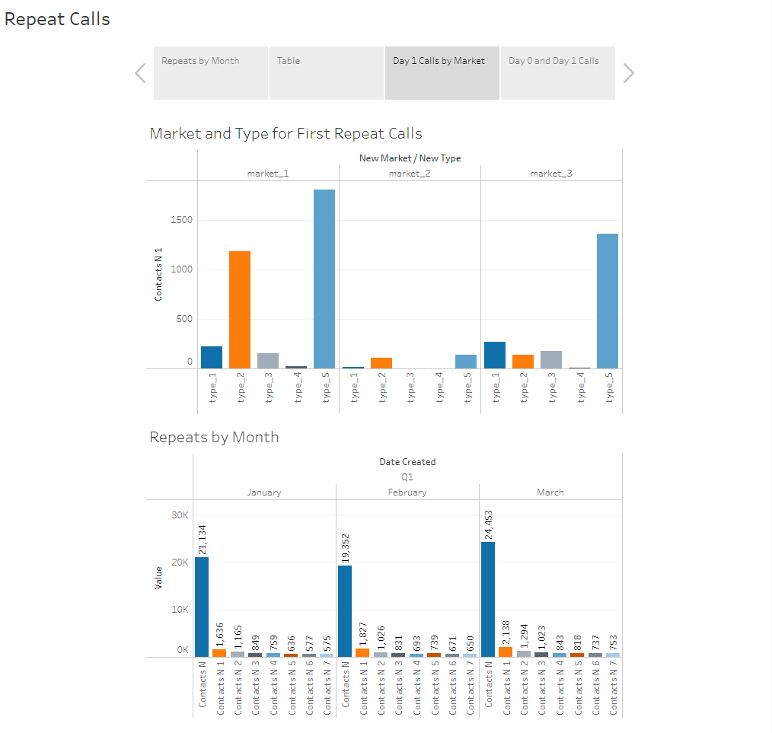

### Calls Across Q1

The final dashboard tab includes two charts to visualize the number of Day 0 calls across markets and problem types and the first repeat calls across markets and problem types. This helps users gain insight into what markets and problems are generating calls in the first quarter of the year, as well as which ones are prompting customers to call again after the first contact.

